Attendance Newsletter – Spring 2024
Our School Attendance target is 97%
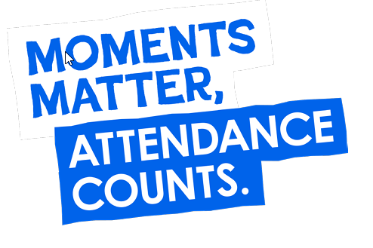
Welcome
Welcome to our second attendance newsletter of the year; the aim is to promote the importance of attendance across The Willows Primary School community. It is really important that we continue to work together to do all we can to prioritise the children’s attendance at school so they can enjoy their learning and socialising with their peers. Nationally there is a big focus on improving attendance and ‘catching up’ following an unsettled few years. At The Willows we want to ensure all of our children attend well so that they can thrive and achieve their potential.
We continue to review reviewing the school registers and parents will be informed if their child has attendance under 93%. This letter can be concerning for parents but our intention is to help and support attendance. It is important that we share children’s attendance at regular intervals so that we are able to quickly support families if children are not attending as they should and we can also help to establish good habits for the future. If your child’s attendance is not quite where we would expect it to be please be assured that the large majority of children will show improvement as the school year progresses and no further contact will be needed.
It is important to note that the attendance percentage on letters does not differentiate between authorised absence due to illness etc. but will reflect the total educational time a child has missed. We do not expect children to attend if they are really poorly but are happy to support them with medicine to make them more comfortable if they have a minor illness. Please visit the School Office if you need to provide paracetamol or other medication. For guidance on whether your child is too ill to attend school please visit https://www.nhs.uk/live-well/is-my-child-too-ill-for-school/.
To Report Absence
Inform the School Office before 8.45am by either;
- Calling 01782 233280, Option 1 to leave a message
- Message the Office via Class Dojo - please don’t just message the teacher in case they aren’t able to pass the message to us
- Email attendance@willowsprimary.com
Our school target and progress
You will see our attendance target is 97% this year – last year we ended on 94.5% which shows we are right to continue to focus on attendance. At the end of the Autumn term we are currently at 95.7% as a whole school. This is showing great progress and as we move out of the winter hopefully this will continue to climb! A total of 383 pupils have attendance over 97% and 184 have 100%. We do still have a number of pupils with an attendance under 90% - this means that they are considered persistently absent and we need to work hard to improve this term. If you would like to check your child’s attendance please Dojo the school office and we will be happy to help.
We have seen a dramatic reduction in the number of children who are arriving late in the mornings. Mr Ken has given me my training and I’m helping him on the roundabout in the morning to keep it running smoothly! Please continue to allow plenty of time for the journey to school.
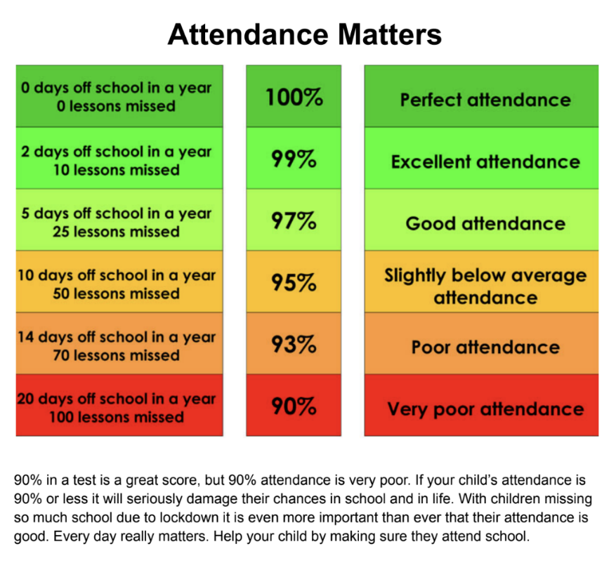
Working Together
We will be working with families to keep you updated on your child’s attendance by sending out letters at key points and you may be invited into school to discuss ways we can help support attendance. If you have any questions or need any help please drop into the School Office or email me at arudge@willowsprimary.com.
Our designated Education Welfare Officer is Mrs Inskip-Clarkson and she will be visiting school on Wednesday 24th January, Wednesday 21st February and Wednesday 20th March if you would like to meet with her or myself to access any support regarding attendance or lateness to school.
Kind Regards
Mrs Rudge

